ASW-Net: A Deep Learning-based Tool for Cell Nucleus Segmentation of Fluorescence Microscopy

Zhe Liu#

Shanghai Mental Health Center, Shanghai Jiao Tong University School of Medicine, School of Biomedical Engineering, Shanghai Jiao Tong University, Shanghai 200030, China

Shanghai Key Laboratory of Psychotic Disorders, Shanghai 200030, China

E-mail: [liuzlm1030@sjtu.edu.cn](mailto:liuzlm1030@sjtu.edu.cn)

Weihao Pan[1]#

Shanghai Mental Health Center, Shanghai Jiao Tong University School of Medicine, School of Biomedical Engineering, Shanghai Jiao Tong University, Shanghai 200030, China

Shanghai Key Laboratory of Psychotic Disorders, Shanghai 200030, China

E-mail: [parrypwhppp@sjtu.edu.cn](mailto:parrypwhppp@sjtu.edu.cn)

Guan Ning Lin[2]*

Shanghai Mental Health Center, Shanghai Jiao Tong University School of Medicine, School of Biomedical Engineering, Shanghai Jiao Tong University, Shanghai 200030, China

Shanghai Key Laboratory of Psychotic Disorders, Shanghai 200030, China

E-mail: [nickgnlin@sjtu.edu.cn](mailto:nickgnlin@sjtu.edu.cn)

Nucleus segmentation of fluorescence microscopy is a critical step in quantifying measurements in cell biology. Automatic and accurate nucleus segmentation has powerful applications in analyzing intrinsic characterization in nucleus morphology. However, existing methods have limited capacity to perform accurate segmentation in challenging samples, such as noisy images and clumped nuclei. In this paper, inspired by the idea of cascaded U-Net (or W-Net) and its remarkable performance improvement in medical image segmentation, we proposed a novel framework called Attention-enhanced Simplified W-Net (ASW-Net), in which a cascade-like structure with between-net connections was used. Results showed that this lightweight model could reach remarkable segmentation performance in the testing set (aggregated Jaccard index, 0.7981). In addition, our proposed framework performed better than the state-of-the-art methods in terms of segmentation performance. Moreover, we further explored the effectiveness of our designed network by visualizing the deep features from the network. Notably, our proposed framework is open-source.

CCS CONCEPTS • Computing methodologies • Artificial intelligence • Computer vision • Computer vision problems • Image segmentation

**Keywords:** Nucleus Segmentation, Fluorescence Microscopy, Deep Learning, Attention Mechanism

1 Introduction

Image segmentation plays a vital role in cell biology in acquiring quantitative measurements [4]. From microscopy-based measurement [13], multiplex imaging analysis [9,11], to high-content screening [2,21], image segmentation is crucial to the characterization of cell signaling and morphology, such as the size and shape.

One of the critical steps of quantifying measurements in fluorescence microscopy is accurate nucleus segmentation. It is the first step for identifying cell borders [15], enabling each cell to characterize. Automatic nucleus segmentation alleviates the problems of assessing subtle visual features by manually inefficiently drawing the nuclear contours [18]. Over the past decades, some significant research efforts have been made to improve the performance of nucleus segmentation [24]. For instance, thresholding [27], watershed algorithm [22,31], and active contour [19,32] are some of the dominant approaches for this segmentation task. However, these methods highly rely on expert knowledge to set parameters, and adjustment parameters are required in different experimental conditions. Moreover, these classical algorithms do not work effectively in some challenging cases, such as noisy images and crowded nuclei[3,4,15].

Deep learning has recently succeeded in image segmentation tasks and often achieves much higher performance on popular benchmarks than traditional methods [25]. From multi-organ segmentation on CT images to [10,33] tumor tissue segmentation on histopathological images [16,29], deep learning has achieved outstanding performance improvement. These segmentation tasks can be formulated as a classification problem of each pixel with a semantic label [25]. Hence, nucleus segmentation can be considered as a problem of classifying each pixel into a semantic category. Some previous works illustrate that deep learning is effective in nucleus segmentation [4,12,34], such as U-Net [14] and W-Net [6]. The architecture of U-Net has been broadly thought of as an encoder convolutional neural network followed by a decoder network. The encoder extracts feature related to the segmentation task, and then the decoder constructs the mask given only such features. In contrast, W-Net is a network with cascaded U-shape architecture [20]. In W-Net, the between-net connections are designed to preserve features from shallow layers to deep layers by concatenation operations [20]. This cascade structure indicates a noticeable accuracy improvement. However, W-Net is a computationally heavy network due to its cascade architecture, thus a large amount of data would be required to train W-Net. In the meanwhile, a longer time is required than U-Net for training a well-fitting model.

Given the importance of nucleus segmentation and only limited data for nucleus segmentation currently, in this study, we revisited the challenge of nucleus segmentation by incorporating the ideas from W-Net. In particular, inspired by U-Net and W-Net, we proposed a novel method for nucleus segmentation, named attention-enhanced simplified W-Net (ASW-Net). Our proposed model is a lightweight network utilizing a cascade-like structure with between-net connections. An attention gate is connected to the convolution block before each upsampling process to extract representative features effectively. In this framework, we utilize the watershed post-processing method to separate adjacent nuclei.

In this study, we propose a novel framework with ASW-Net for the nucleus segmentation of fluorescence microscopy. Attention gates are applied on ASW-Net for better learning ability. Moreover, we visualize the deep features extracted from ASW-Net to interpret how this model effectively improves segmentation performance.

We have released ASW-Net as a publicly available segmentation tool for the community. The pre-trained model and all support materials are available at <https://github.com/Liuzhe30/ASW-Net>.

2 Materials and Methods

2.1 Benchmark Dataset

We employed image set BBBC039[21], available from the Broad Bioimage Benchmark Collection (<http://www.broad.mit.edu/bbbc>). This image set only includes a channel of DNA of a single field of view. This collection has around 23,165 nuclei annotated by expert biologists, including variant perturbations from one experiment. The dataset consists of 200 images, each of size 520×696 pixels. We used the same data partitions as Broad Institute suggests comparing results with previous work. Hence, the collection is split into 100 training, 50 validation, and 50 testing images. Hence, more than 72 million pixels were used in our pixel classification task for nucleus segmentation.

2.2 Algorithm Framework

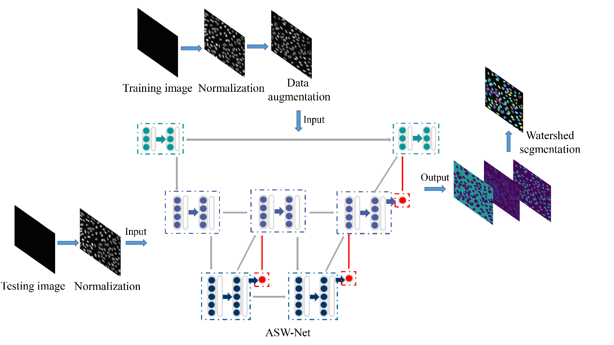

Figure . Overview of the proposed approach for nuclear instance segmentation. This pipeline contains three parts: image pre-processing, network architecture, and image post-processing.

Our overall framework for nuclear instance segmentation contains three parts: image pre-processing, network architecture, and image post-processing (see Figure 1). As for the pre-processing method, we first applied gray-scale normalization making contours and instances clearer in the source image. To avoid as much over-fitting as possible, we also utilized some data augmentation operations for the training set (rotation and flip). Then, the processed images were fed into our proposed deep-learning network ASW-Net for training or testing to predict whether a given pixel is on the edge of the nucleus, inside the nucleus, or in the background. The detailed structure of ASW-Net is demonstrated in the next section. Considering the overlapped nuclei in the original predicted results, we implemented the watershed algorithm [28] to alleviate the overlapping problem and improve prediction accuracy. After the procedures described above, we obtained the final segmentation results.

2.3 Model Design

2.3.1 Network Architecture

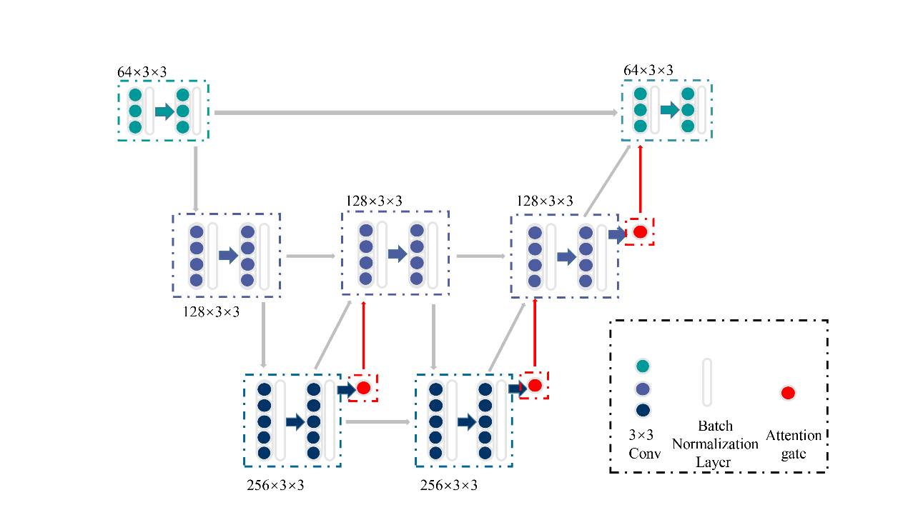

Figure . The structure of ASW-Net. There are three downsampling processes (encoding phase), three upsampling processes (decoding phase), and three attention gates, which form the shape of a ‘W’. The green and blue dots represent the convolutional blocks, while the white transparent boxes represent the batch normalization layers and the red dots represent the attention gates.

Inspired by the classical structures of U-Net [14], W-Net [20], and some pioneered research works, we proposed ASW-Net, a deep learning-based tool for cell nucleus segmentation of fluorescence microscopy. As a simplified W-net, ASW-Net can extract more features from raw images compared with U-net, and it is lighter than W-net at the same time. The attention mechanism also endows the model with better learning ability and interpretability.

Figure 2 shows the detailed structure of ASW-Net, which contains three downsampling processes (encoding phase), three up-sampling processes (decoding phase), and three attention gates. First, the input images are fed into two successive down-sampling processes, followed by an up-sampling process. Since the original input consists of features from a shallow level and carries useless noise with a high probability, the first upsampling process does not feed it back into the model. To learn the deeper features more purely, we only decode and re-enter the information generated before the second downsampling.

After this, we continued to conduct a downsampling process followed by two up-sampling processes and combine the original input into the output information to merge the deep and shallow features. Besides, batch normalization layers were implemented to reduce saturation [5], and attention gates were attached to all the upper sampling blocks to increase the accuracy of predicting the boundary of objects. We then finally obtained the classification output by combining the original input with the upsampled result and convolving them.

2.3.2 Implementation Details

Our model was implemented, trained, and tested using the open-source software library Keras [17] and Tensorflow [1] on Nvidia Tesla v100 GPUs. Main hyperparameters, such as the kernel size of convolutional blocks and the learning rate, were explored. Besides, we also adopted an early stopping strategy and a save-best strategy. When the validation loss did not reduce in 10 epochs during training time, the training process would be stopped, and the best model parameters would be saved. In all cases, the weights were initialized by default setting in Keras; the parameters were trained using an RMSProp optimizer [30] to change the learning rate during model training dynamically. Our proposed network was trained by minimizing the weighted cross-entropy loss function [26] for semantic segmentation.

2.4 Performance Evaluation metrics

A commonly used evaluation metric for nucleus segmentation is Aggregated Jaccard Index (AJI). To quantitatively evaluate the performance of ASW-Net and other nucleus segmentation methods, we adopted four measures, including AJI [18], Dice coefficient (DICE1) [7], ensemble Dice (DICE2) [29], panoptic quality (PQ) [12]. PQ is the product of Detection Quality (DQ) and Segmentation Quality (SQ)

3 Results

3.1 Performance of ASW-Net and Other Existing Nucleus Segmentation Methods

Table . The performance comparison between ASW-Net and other existing methods.

| Method | DICE1 | DICE2 | AJI | DQ | SQ | PQ |
| --- | --- | --- | --- | --- | --- | --- |
| CellProfiler[23] | 63.645 | 41.050 | 44.053 | 34.729 | 72.417 | 27.170 |
| U-Net[4] | 89.094 | 86.916 | 78.717 | **92.395** | 79.562 | 73.646 |
| SW-Net | 89.282 | 87.466 | 79.219 | 91.666 | 80.043 | 73.505 |
| ASW-Net | **89.642** | **87.518** | **79.806** | 91.666 | **80.627** | **74.058** |

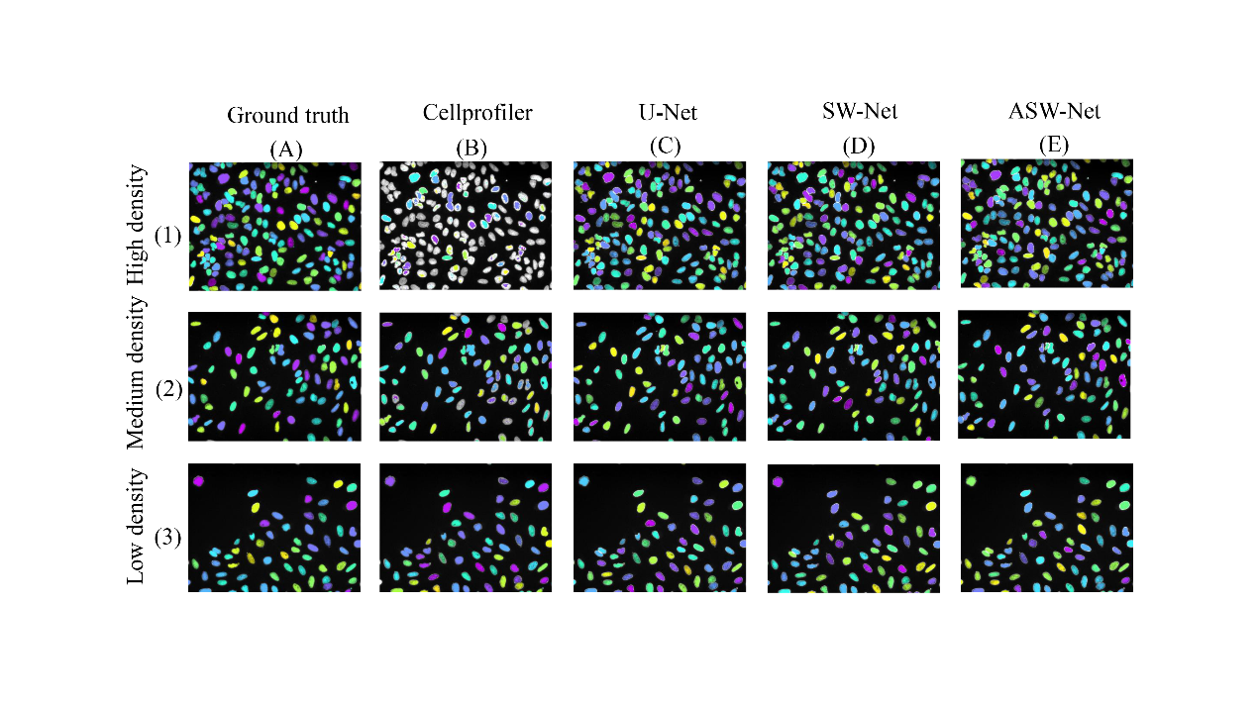

Figure . A visualized comparison between ASW-Net and other existing methods against the ground truth. Three images with different nuclear distribution densities were randomly selected for this study.

To evaluate the prediction performance of our proposed method, we tested ASW-Net against CellProfiler [23], U-Net [14], and SW-Net(ASW-Net without attention gates) with ground truth as a baseline. Experimental results show that ASW-Net achieved satisfactory accuracy in classification even with insufficient labeled training samples. It can be seen in Table 1 that among all of the tested methods, ASW-Net gets the highest score for all indicators except DQ.

When it comes to the classification stability of ASW-Net, three images with different nuclear distribution densities were randomly selected for a case study. As shown in Figure 3, CellProfiler performed poorly in the case of high nuclear density (see Figure 3(B)(1)), while ASW-Net generates reliable masks no matter in the case of low, medium, or high nuclear density. Furthermore, SW-Net with the attention gates performed better than the network without the attention mechanism, proving the necessity of embedding the attention mechanism in our method.

3.2 Ablation Study

Table . Ablation study of ASW-Net.

| Aspect | System variant | AJI | AJI |
| --- | --- | --- | --- |
|  | ASW-Net | **79.806** | - |
| Attention | No Attention | 79.219 | -0.587 |
| Augmentation | No rotation | 78.355 | -1.451 |
|  | No flip | 78.592 | -1.214 |
| Post-processing | Watershed | **79.811** | +0.005 |

To examine whether a particular component of ASW-Net was vital or necessary, we carried out an ablation study by removing some network elements. The experiments performed in this section shared the same features and hyper-parameters. As is shown in Table 2, the implementation of attention mechanisms, data augmentation (rotation and flip), and post-processing(watershed) all contribute to the proposed method. Specifically, the addition of image rotation and flip significantly improved the prediction performance (∆AJI = -1.451 for no rotation, ∆AJI = -1.214 for no flip), which may be due to the undiversified training dataset. Moreover, the data augmentation also helped improve the generalization capability of the model.

Attention gates were beneficial for achieving better prediction accuracy (∆AJI = -0.587 for no attention) at the same time. On the one hand, the introduction of attention gates made the number of parameters increase, thus enhancing the learning ability of the model. On the other hand, the attention gates attached in the up-sampling process conduced to more efficient feature extraction.

The introduction of post-processing also had a positive effect on the prediction performance (∆AJI = +0.005), possibly because the watershed algorithm was helpful to separate the connected cell nucleus [28]. However, we did not observe a significant improvement in the segmentation performance by the watershed algorithm because ASW-Net could already predict boundary class effectively. Hence, the clumped nuclei would be separated well after the evaluation of ASW-Net.

3.3 Visualization of Deep Features Extracted from Images

As an automatic feature extraction process, deep learning would learn high-level abstract features from original inputs [8]. Thus, to further explore the effectiveness of convolution blocks at different depths of ASW-Net, we visualized the feature map of each convolutional layer, and the results are shown in Figure 4. As described earlier, the convolution block before the first upsampling (Figure 4(B)) and before the second upsampling (Figure 4(D)) incorporated the deepest abstract features. We observed that the feature map generated from the shallow convolution layer was much closer to the actual images. Besides, comparing the visualization results of the first convolution block (Figure 4(A)) with the last convolution block (Figure 4(E)), we observed that the final convolutional layer reflected the most favorable information for segmentation: the center of the nucleus and the edge of the nucleus are separated, which also proves the effectiveness of the neural network.

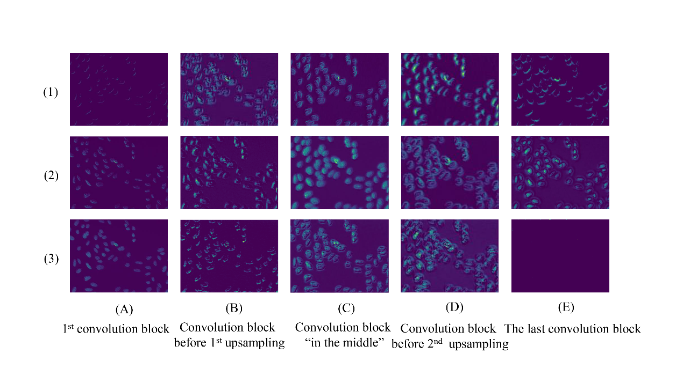

Figure . Visualization of feature maps extracted by convolution layers at different depths of ASW-Net. (A) to (E) represent the features extracted by the first convolution block, the convolution block before the first upsampling, the convolution block in the middle, the convolution block before the second upsampling, and the last convolution block, respectively.

4 Discussion

Nucleus segmentation is a prerequisite for automated downstream analysis, including characterization of nucleus morphology, identification and detection of cells, and quantitative measurement of protein expression. However, manually drawing the nuclear contours is time-consuming and laborious. Automatic and accurate nucleus segmentation would alleviate this difficulty and enables biologists to yield insights into intrinsic features of nucleus morphology.

In this study, we proposed a deep learning-based tool, ASW-Net, to automatically segment the nucleus of fluorescent microscopy by integrating advantages of attention mechanism, W-Net, and adopting a cascade-like structure with between-net connections. We have shown that our lightweight model outperforms the-state-of-art methods in segmentation performance. We also showed that utilizing the attention mechanism would provide information about nucleus segmentation, leading to a much-improved performance. The attention mechanism endows our proposed tool with better learning ability and interpretability, making our tool likely to translate well to practical usage.

Although our proposed tool achieves promising performance in nucleus segmentation of fluorescent microscopy, there are several open technical problems from the aspect of deep learning techniques, such as a theoretical explanation of our architecture effectiveness and tuning hyper-parameters for an optimal model.

5 Conclusion

We implemented ASW-Net as a publicly available segmentation tool for the research community. The model achieves remarkable performance in nucleus segmentation. In the future, our model can be retrained on other types of nucleus images, such as highly multiplexed imaging data.

**Author Contributions**

ZL, WP, and GNL conceived the idea of this research. ZL designed and implemented the model structure of ASW-Net. WP collected and processed the dataset, trained, evaluated, and visualized the model. ZL and WP wrote the manuscript, and GNL supervised the manuscript. All authors contributed to the article and approved the submitted version.

**Funding**

This work was supported by grants from the National Natural Science Foundation of China (nos. 81971292), the Program for Professor of Special Appointment (Eastern Scholar) at Shanghai Institutions of Higher Learning (no. 1610000043), and the Innovation Research Plan supported by Shanghai Municipal Education Commission (ZXWF082101).

**Acknowledgments**

The support of the Center of High-Performance Computing (HPC) of Shanghai Jiao Tong University for this work is gratefully acknowledged.

References

[1] Martín Abadi. 2016. TensorFlow: learning functions at scale. *ACM SIGPLAN Not.* (2016). DOI:https://doi.org/10.1145/3022670.2976746

[2] Michael Boutros, Florian Heigwer, and Christina Laufer. 2015. Microscopy-Based High-Content Screening. *Cell*. DOI:https://doi.org/10.1016/j.cell.2015.11.007

[3] Juan C. Caicedo, Allen Goodman, Kyle W. Karhohs, Beth A. Cimini, Jeanelle Ackerman, Marzieh Haghighi, Cher Keng Heng, Tim Becker, Minh Doan, Claire McQuin, Mohammad Rohban, Shantanu Singh, and Anne E. Carpenter. 2019. Nucleus segmentation across imaging experiments: the 2018 Data Science Bowl. *Nat. Methods* (2019). DOI:https://doi.org/10.1038/s41592-019-0612-7

[4] Juan C. Caicedo, Jonathan Roth, Allen Goodman, Tim Becker, Kyle W. Karhohs, Matthieu Broisin, Csaba Molnar, Claire McQuin, Shantanu Singh, Fabian J. Theis, and Anne E. Carpenter. 2019. Evaluation of Deep Learning Strategies for Nucleus Segmentation in Fluorescence Images. *Cytom. Part A* (2019). DOI:https://doi.org/10.1002/cyto.a.23863

[5] Jia-Ren Chang and Yong-Sheng Chen. *Batch-normalized Maxout Network in Network*.

[6] Wanli Chen, Yue Zhang, Junjun He, Yu Qiao, Yifan Chen, Hongjian Shi, and Xiaoying Tang. 2018. W-Net: Bridged U-Net for 2D Medical Image Segmentation. *arXiv Prepr. arXiv1807.04459* (2018).

[7] Lee R. Dice. 1945. Measures of the Amount of Ecologic Association Between Species. *Ecology* (1945). DOI:https://doi.org/10.2307/1932409

[8] Gonzalo Farias, Sebastián Dormido-Canto, Jesús Vega, Giuseppe Rattá, Héctor Vargas, Gabriel Hermosilla, Luis Alfaro, and Agustín Valencia. 2016. Automatic feature extraction in large fusion databases by using deep learning approach. *Fusion Eng. Des.* (2016). DOI:https://doi.org/10.1016/j.fusengdes.2016.06.016

[9] Michael J. Gerdes, Christopher J. Sevinsky, Anup Sood, Sudeshna Adak, Musodiq O. Bello, Alexander Bordwell, Ali Can, Alex Corwin, Sean Dinn, Robert J. Filkins, Denise Hollman, Vidya Kamath, Sireesha Kaanumalle, Kevin Kenny, Melinda Larsen, Michael Lazare, Qing Li, Christina Lowes, Colin C. McCulloch, Elizabeth McDonough, Michael C. Montalto, Zhengyu Pang, Jens Rittscher, Alberto Santamaria-Pang, Brion D. Sarachan, Maximilian L. Seel, Antti Seppo, Kashan Shaikh, Yunxia Sui, Jingyu Zhang, and Fiona Ginty. 2013. Highly multiplexed single-cell analysis of formalinfixed, paraffin-embedded cancer tissue. *Proc. Natl. Acad. Sci. U. S. A.* (2013). DOI:https://doi.org/10.1073/pnas.1300136110

[10] Eli Gibson, Francesco Giganti, Yipeng Hu, Ester Bonmati, Steve Bandula, Kurinchi Gurusamy, Brian Davidson, Stephen P. Pereira, Matthew J. Clarkson, and Dean C. Barratt. 2018. Automatic Multi-Organ Segmentation on Abdominal CT with Dense V-Networks. *IEEE Trans. Med. Imaging* (2018). DOI:https://doi.org/10.1109/TMI.2018.2806309

[11] Charlotte Giesen, Hao A.O. Wang, Denis Schapiro, Nevena Zivanovic, Andrea Jacobs, Bodo Hattendorf, Peter J. Schüffler, Daniel Grolimund, Joachim M. Buhmann, Simone Brandt, Zsuzsanna Varga, Peter J. Wild, Detlef Günther, and Bernd Bodenmiller. 2014. Highly multiplexed imaging of tumor tissues with subcellular resolution by mass cytometry. *Nat. Methods* (2014). DOI:https://doi.org/10.1038/nmeth.2869

[12] Simon Graham, Quoc Dang Vu, Shan E.Ahmed Raza, Ayesha Azam, Yee Wah Tsang, Jin Tae Kwak, and Nasir Rajpoot. 2019. Hover-Net: Simultaneous segmentation and classification of nuclei in multi-tissue histology images. *Med. Image Anal.* (2019). DOI:https://doi.org/10.1016/j.media.2019.101563

[13] Y. Gu. 2003. Automated scanning electron microscope based mineral liberation analysis. *J. Miner. Mater. Charact. Eng.* (2003).

[14] K. He, X. Zhang, S. Ren, and J. Sun. 2015. U-net: Convolutional networks for biomedical image segmentation," in International Conference on Medical image computing and computer-assisted intervention. *Lect. Notes Comput. Sci. (including Subser. Lect. Notes Artif. Intell. Lect. Notes Bioinformatics)* (2015).

[15] Reka Hollandi, Abel Szkalisity, Timea Toth, Ervin Tasnadi, Csaba Molnar, Botond Mathe, Istvan Grexa, Jozsef Molnar, Arpad Balind, Mate Gorbe, Maria Kovacs, Ede Migh, Allen Goodman, Tamas Balassa, Krisztian Koos, Wenyu Wang, Juan Carlos Caicedo, Norbert Bara, Ferenc Kovacs, Lassi Paavolainen, Tivadar Danka, Andras Kriston, Anne Elizabeth Carpenter, Kevin Smith, and Peter Horvath. 2020. nucleAIzer: A Parameter-free Deep Learning Framework for Nucleus Segmentation Using Image Style Transfer. *Cell Syst.* (2020). DOI:https://doi.org/10.1016/j.cels.2020.04.003

[16] Xiansong Huang, Hongliang He, Pengxu Wei, Chi Zhang, Juncen Zhang, and Jie Chen. 2019. Tumor tissue segmentation for histopathological images. In *1st ACM International Conference on Multimedia in Asia, MMAsia 2019*. DOI:https://doi.org/10.1145/3338533.3372210

[17] Nikhil Ketkar. 2017. Introduction to Keras. In *Deep Learning with Python*. Apress, 97–111. DOI:https://doi.org/10.1007/978-1-4842-2766-4_7

[18] Neeraj Kumar, Ruchika Verma, Sanuj Sharma, Surabhi Bhargava, Abhishek Vahadane, and Amit Sethi. 2017. A Dataset and a Technique for Generalized Nuclear Segmentation for Computational Pathology. *IEEE Trans. Med. Imaging* (2017). DOI:https://doi.org/10.1109/TMI.2017.2677499

[19] Gang Li, Tianming Liu, Ashley Tarokh, Jingxin Nie, Lei Guo, Andrew Mara, Scott Holley, and Stephen T.C. Wong. 2007. 3D cell nuclei segmentation based on gradient flow tracking. *BMC Cell Biol.* (2007). DOI:https://doi.org/10.1186/1471-2121-8-40

[20] Hongying Liu, Xiongjie Shen, Fanhua Shang, Feihang Ge, and Fei Wang. 2019. CU-Net: Cascaded U-Net with Loss Weighted Sampling for Brain Tumor Segmentation. In *Lecture Notes in Computer Science (including subseries Lecture Notes in Artificial Intelligence and Lecture Notes in Bioinformatics)*. DOI:https://doi.org/10.1007/978-3-030-33226-6_12

[21] Vebjorn Ljosa, Katherine L. Sokolnicki, and Anne E. Carpenter. 2012. Annotated high-throughput microscopy image sets for validation. *Nature Methods*. DOI:https://doi.org/10.1038/nmeth.2083

[22] Norberto Malpica, Carlos Ortiz De Solórzano, Juan José Vaquero, Andrés Santos, Isabel Vallcorba, José Miguel García-Sagredo, and Francisco Del Pozo. 1997. Applying watershed algorithms to the segmentation of clustered nuclei. *Cytometry* (1997). DOI:https://doi.org/10.1002/(SICI)1097-0320(19970801)28:4<289::AID-CYTO3>3.0.CO;2-7

[23] Claire McQuin, Allen Goodman, Vasiliy Chernyshev, Lee Kamentsky, Beth A. Cimini, Kyle W. Karhohs, Minh Doan, Liya Ding, Susanne M. Rafelski, Derek Thirstrup, Winfried Wiegraebe, Shantanu Singh, Tim Becker, Juan C. Caicedo, and Anne E. Carpenter. 2018. CellProfiler 3.0: Next-generation image processing for biology. *PLoS Biol.* (2018). DOI:https://doi.org/10.1371/journal.pbio.2005970

[24] Erik Meijering. 2012. Cell Segmentation: 50 Years Down the Road. *IEEE Signal Process. Mag.* (2012).

[25] Shervin Minaee, Yuri Y. Boykov, Fatih Porikli, Antonio J. Plaza, Nasser Kehtarnavaz, and Demetri Terzopoulos. 2021. Image Segmentation Using Deep Learning: A Survey. *IEEE Trans. Pattern Anal. Mach. Intell.* (2021). DOI:https://doi.org/10.1109/TPAMI.2021.3059968

[26] Mostefa Ben naceur, Mohamed Akil, Rachida Saouli, and Rostom Kachouri. 2020. Fully automatic brain tumor segmentation with deep learning-based selective attention using overlapping patches and multi-class weighted cross-entropy. *Med. Image Anal.* (2020). DOI:https://doi.org/10.1016/j.media.2020.101692

[27] Otsu and N. 1996. A threshold selection method from gray-level histograms. *IEEE Trans. Syst. Man Cybern.* (1996).

[28] J. M. Sharif, M. F. Miswan, M. A. Ngadi, Md Sah Hj Salam, and Muhammad Mahadi Bin Abdul Jamil. 2012. Red blood cell segmentation using masking and watershed algorithm: A preliminary study. In *2012 International Conference on Biomedical Engineering, ICoBE 2012*. DOI:https://doi.org/10.1109/ICoBE.2012.6179016

[29] Quoc Dang Vu, Simon Graham, Tahsin Kurc, Minh Nguyen Nhat To, Muhammad Shaban, Talha Qaiser, Navid Alemi Koohbanani, Syed Ali Khurram, Jayashree Kalpathy-Cramer, Tianhao Zhao, Rajarsi Gupta, Jin Tae Kwak, Nasir Rajpoot, Joel Saltz, and Keyvan Farahani. 2019. Methods for segmentation and classification of digital microscopy tissue images. *Front. Bioeng. Biotechnol.* (2019). DOI:https://doi.org/10.3389/fbioe.2019.00053

[30] Olga Wichrowska, Niru Maheswaranathan, Matthew W. Hoffman, Sergio Gómez Colmenarejo, Misha Denii, Nando De Freitas, and Jascha Sohl-Dickstein. 2017. Learned optimizers that scale and generalize. In *34th International Conference on Machine Learning, ICML 2017*.

[31] Lipeng Xie, Jin Qi, Lili Pan, and Samad Wali. 2020. Integrating deep convolutional neural networks with marker-controlled watershed for overlapping nuclei segmentation in histopathology images. *Neurocomputing* (2020). DOI:https://doi.org/10.1016/j.neucom.2019.09.083

[32] Chenyang Xu and Jerry L. Prince. 1998. Snakes, shapes, and gradient vector flow. *IEEE Trans. Image Process.* (1998). DOI:https://doi.org/10.1109/83.661186

[33] Xiaofeng Yang, Yang Lei, Yingzi Liu, Sibo Tian, Kristin Higgins, Jonathan J. Beitler, David S. Yu, Xiaojun Jiang, Tian Liu, Walter J. Curran, Yi Fang, Xue Dong, and Tonghe Wang. 2019. Automatic multi-organ segmentation in thorax CT images using U-Net-GAN. DOI:https://doi.org/10.1117/12.2512552

[34] Zitao Zeng, Weihao Xie, Yunzhe Zhang, and Yao Lu. 2019. RIC-Unet: An Improved Neural Network Based on Unet for Nuclei Segmentation in Histology Images. *IEEE Access* (2019). DOI:https://doi.org/10.1109/ACCESS.2019.2896920

Authors’ Information

|  |  |  |  |
| --- | --- | --- | --- |
| Your Name | Title* | Research Field | Personal website |
| Zhe Liu | PhD Student | Bioinformatics | https://github.com/Liuzhe30/ |
| Weihao Pan | Master Student | Bioinformatics | https://github.com/ppparry |
| Guan Ning Lin | Associate Professor | Bioinformatics | https://bmi.sjtu.edu.cn/ |

1. # These authors contributed equally to this work.
2. * Corresponding author